Introduction/How it was handled
In Boeing history, the 737 max is the fastest-selling plane as it racks more than 5000 orders. There was a deceleration by the CEO, Kevin McAllister that there will be a change in the single-aisle market face. However, two lethal crashes of the 737 max with a total of 346 fatalities have led to a change in picture and a crisis is now facing Boeing. On Monday, 29th October 2018. Lion Air Flight 610 at 6: 20 AM local time took off from Jakarta heading to PangkalPinag. Twelve minutes after taking off, it is when the plane crashed into the Java Sea and killed 189 passengers in total with an inclusion of the crew. Five months later, another Boeing 737 Max on 10th March 2019, took off from Addis Ababa, Ethiopia heading to Nairobi, Kenya on Sunday at 8: 38 AM. After the take-off, the plane crashed six minutes later near Bishoftu town, Ethiopia killing all the occupants, 157 in total. International regulators such as Chinese and Europeans are even expected to even take longer periods in response to clear the Max to fly. This paper attempts to explain the dilemma existing on Boeing 737 max on whether to fly or not through an analysis of what the problem was and the safety issues arising from the crashes following the grounding of all Boeing 737 max by the FAA and most countries around the world.
First cause of the crashes (The angle of Attack Sensor)
The angle of attack (AOA) sensor is a device highly linked to the Boeing 737 Max software. The device is highly scrutinized have led to the emergence of two deadly crashes that led to the death of all occupants. As commonly known, the angle of attack sensor sends data to the software system of 737 Max pushing down the aircraft's nose if an imminent stall is sensed. The software is believed to have played a role in the two fatal crashes, Lion Air and Ethiopian Airlines jets triggered by AOA sensors erroneous data. According to Joseph Katz, the crux of the problem is the angle of attack. With this in mind, a glitch with sensors highly led to the crashes. It appears that the wrong information was sent by the sensor to the flight control system indicating the attack angle was too large and approaching stall. The aircraft system was steered by pitching the nose down to correct the attack angle. It came to the realization it was a wrong command by the pilots and trying to override the system appeared that figuring out how to override was hectic. Eventually, the planes crashed after going into a dive. The conclusions were made after an investigation of reports that were present in technical industry publications.
Second cause of the crashes Boeing
Boeing was aware of the faulty system issues, yet it failed to do anything about the MCAS system. This led to the two crashes killing 346 people in total. Boeing CEO, Muilenburg was confronted with documents outlining potential catastrophic consequences knowledge and offered no answers to why the faulty system was approved. However, it is clear that the engineers gave warnings and therefore the need to scrap the program. Additionally, several texts were cited in terms of extremely erratic software behaviour in 2016 of flight simulation. However; the engineers who made the decision to use the sensor knowingly the issues with it, did not follow the code of ethics where it says “Engineers shall hold paramount the safety, health, and welfare of the public” (NSPE,2019). Also, the engineers in Boeing did a good example of whistle blowing when they sent the texts where they cited multiple weird behaviours with the sensor, but unfortunately the higher engineers did not give attention to it.
In 2016, Boeing chief technical pilot told another employee on the 737 Max project that was egregious issues with the automated MCAS system in the jet two years before the fatal crashes attributed to the system. “Internal instant messages that Mark Forkner sent in 2016 were found and reported first on the messages.” (Dieusaert, 2017). However in the virtue ethics point of view where it is described as “ Virtue ethics focuses on being honest, loyal”, the chief technical pilot during the testing did not mention the issues accruing while testing the plane and he did not commit to his duty ethics where he should have mentioned the issues immediately and not waited two years.
There are claims by Boeing that the pilot's training was enough to control the plane by bypassing the sensor. Boeing insists that the pilots could deal with any problems by following the emergency procedures checklist. The findings that were released in Ethiopia suggest the prescribed procedures that were prescribed initially were followed after the malfunction of the anti-stall system. They went ahead to shut off the electricity that allows pushing the plane nose down in the automated software and the jet manual control was taken. The captain instructed the co-pilot to pull up three times to attempt to right the plane. However, control could not be regained. At coronial speed, the plane hit the ground about four minutes after the initial activation of the system and the occupants lost their lives. It came out that the pilot could not recover the aircraft with the trained procedures.
Third cause of the crashes The Lion Air crash safety issues
A lion Airplane crashed carrying 189 people into the Indonesian Island of Java Sea off shortly after taking off the Jakarata capital. In its short history, Lion Air has been under several serious incidents while Indonesia saw a number of its carriers banned from operating in Europe. Lion Air had a track record whereby pilots would work to the point of exhaustion. There were also instances of fake pilot training certification and even pilots could be forced to fly planes with worries of being unsafe with an inclusion of the one that crashed. Despite the urgency to enhance safety recommendations for improvements, rather than taking impressive and immediate actions, the company seems to mull the next steps. In 2016, A Lion Air jet suffered engine oil loss and the pilot had to shut down the flight engine. These information shows that the Lion Air did not take in consideration their duty ethics by ensuring the safety of the public. They could have done better job on maintenance and recruiting their pilots. Also, I think the bad reputation of safety of the Lion Air caused other airlines not to ground the Boeing 737max.
Analysis/How should it be handled
Boeing 737 Max is still folding today and will continue for some time. Since then, there have been important lessons that have been learned and relearned from an ethics side of view. Concerning the specific code of ethics, ethical theories, values, and safety, it would have been effective to handle the issue through prioritizing the public good and the public safety more specifically. Protecting the public welfare, health and safety is the paramount responsibility of an engineer as stated by major engineering society’s contemporary ethics code. In the performance of the engineering duties, engineers must hold the three into account according to the American Institute of Aeronautics and Astronautics Code of Ethics. I would have held and strive to comply with ethical designs suitable development practices. Additionally, I would have disclosed the factors promptly which would have endured the environment or the public. It would have been effective to approve software of the angle of the attack sensor in the belief that it was well-founded with the considerations of meeting safety, specifications, did not diminish life quality passed the tests appropriately and did not in any way cause harm to the environment. This is developing a software Engineering Code of Ethics in compliance with the Association for Computing Machinery and IEEE Computer Society.
Schedule and cost are factors that an engineer responsibility ethically should not preclude. Constraints such as limitations of resources and time are what engineers grapple with. I would have had concerns legitimately about the Boeing losing contacts to the competitors. Being an engineer, my top priority would have been public welfare and safety. It would have been easier to determine that it was a clear violation of code of ethics in engineering in the 737 Max developments by the aforementioned software and other errors in design.
The central issue ethically circulates mainly on the decisions to use MCAS. I would have made sure the design goals were met and advocate for an expensive hardware change to meet the considerations that were put in place. I would make sure that such software fixes did not place a high safety burden making it possible to handle overall. With this in place, it would have been possible to use MCAS in making significant hardware configuration change by compounding through redundancy provisions for components prone to fail. Pilots would have received documentation clearly and receive relevant training making it possible to manage the hand-off with an automated system effectively. The lesson now appears to have been learned at the expense of many lives lost.
The problem of many hands is relevant in the 737 Max case through actions or inaction by complex, large organizations therefore government and corporate entities in this case. The problem of many hands at a high-level abstraction involve the idea that assigning accountability is difficult in the collective action face more specific in a computerized society. In the work of many hands in a mishap, knowing who is to blame is difficult due to lack of converging of immediate and salient casual antecedents with the decision-making locus. There was no satisfaction of the blame conditions such as when a single person is held responsible for harm occurrence. When there is an involvement of a number of people in a computer device designing as evident in the 737 Max, the occurrence of a serious failure leads to absolving from responsibility through indicating too many decisions and too many people were involved therefore failure for an individual in knowing the occurrence of a problem. The problem of many hands was present in large scale ethical failure in the 737 max. The Boeing 737 Max case has a number of possible difficulties present in moral responsibility due to many hands problem. These include and are not limited to: engines reposition decision, decision to rely on only one AOA senor in MCAS designing, decision to not train properly nor inform pilots about MCAS system and the decision to make the dynamic instability of the jet with MCAS.
While it may be difficult to allocate the decisions of the overall responsibility precisely, there is a reflection of fundamental errors that led to the faulty crash of 737 Max. Arguably the FAA engineers and Boeing either participated in or were aware of the decisions and may have had opportunities to redirect or reconsider the decisions. Responsible engineering professionals should make it possible to address issues even when they fail to cause problems or solely cause it. Reports indicate at least there was an expression of reservations by one Boeing engineer about the MCAS design. Since then internal ethics complaints have been filed and several employees have gone public with the 737 Max concerns. However, tragic results came out with the flawed design.
Conclusion
The crashing of the Boeing 737 Max was as a result of a bad call of a sensor. The automated system of the Boeing was activated erroneously therefore an occurrence of events that were beyond the pilot’s control leading to the crash. To avoid any future occurrence of future crashes of Boeing 737 Max, there is the need to take the right initiatives. However, technology comes with downsides no matter the benefits. People can be confused and made careless by computers, smartphones, and cameras which in modern aircraft us true for pilots. Boeing should take all the necessary precautions to ensure all the set guidelines are adhered to and followed to minimize aircrafts failure since losing such a huge number of people in one instance in a way that could have been avoided is relevant.
References

Hailey, K. (2006). Code of professional conduct: Standards & ethics for the investigative profession. Tucson, AZ: Lawyers & Judges Pub.

Fowler, M. D. M. (2010). Guide to the code of ethics for nurses: Interpretation and application.

Greenberg, J. S. (2001). The code of ethics for the health education profession: A case study book. Boston: Jones and Bartlett Publishers.

Dieusaert, T. (2017). Computer Crashers: When airplanes systems fail.
Code of Ethics. (2019). Retrieved August 03, 2020, from https://www.nspe.org/resources/ethics/code-ethics
Singh, B., Singh, J., Jay Singh Deputy Content Manager - Jay’s extensive travels and experience of premium products has given him incredible insight into the wider landscape of commercial aviation. Cited by TIME and Intelligent Aerospace, & Articles:, R. (2020, July 22). FAA Outlines Remaining Steps For Boeing 737 MAX Certification. Retrieved August 03, 2020, from https://simpleflying.com/remaining-steps-737-max/
SDSU: What Caused Boeing's 737 Max Crashes. (2019). Retrieved August 03, 2020, from https://newscenter.sdsu.edu/sdsu_newscenter/news_story.aspx?sid=77807
Lion Air crash: Boeing 737 plane crashes in sea off Jakarta. (2018, October 29). Retrieved August 03, 2020, from https://www.bbc.com/news/world-asia-46014463
Boeing staff texted about 737 Max issue in 2016. (2019, October 18). Retrieved August 03, 2020, from https://www.bbc.com/news/business-50101766

https://transportation.house.gov/imo/media/doc/TI%20Preliminary%20Investigative%20Findings%20Boeing%20737%20MAX%20March%202020.pdf

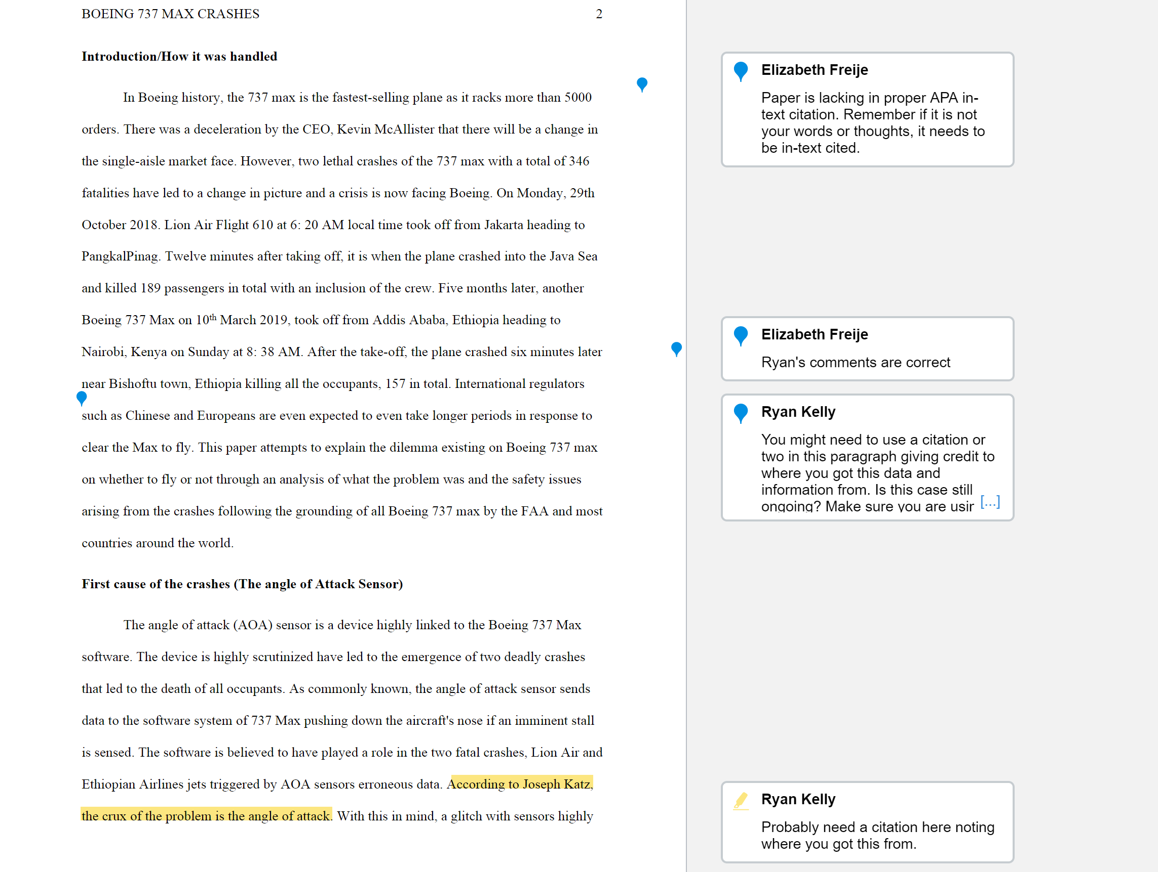
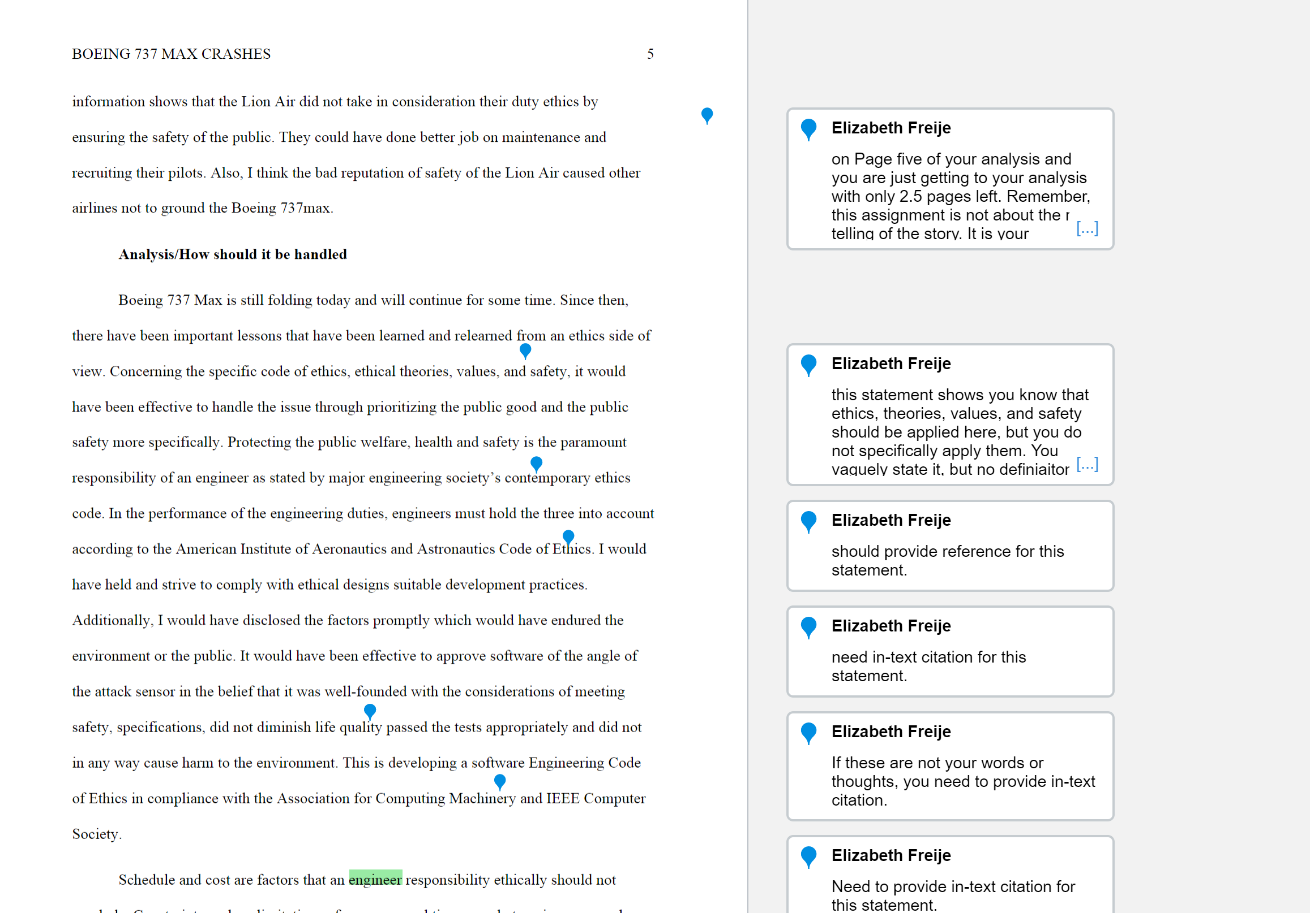
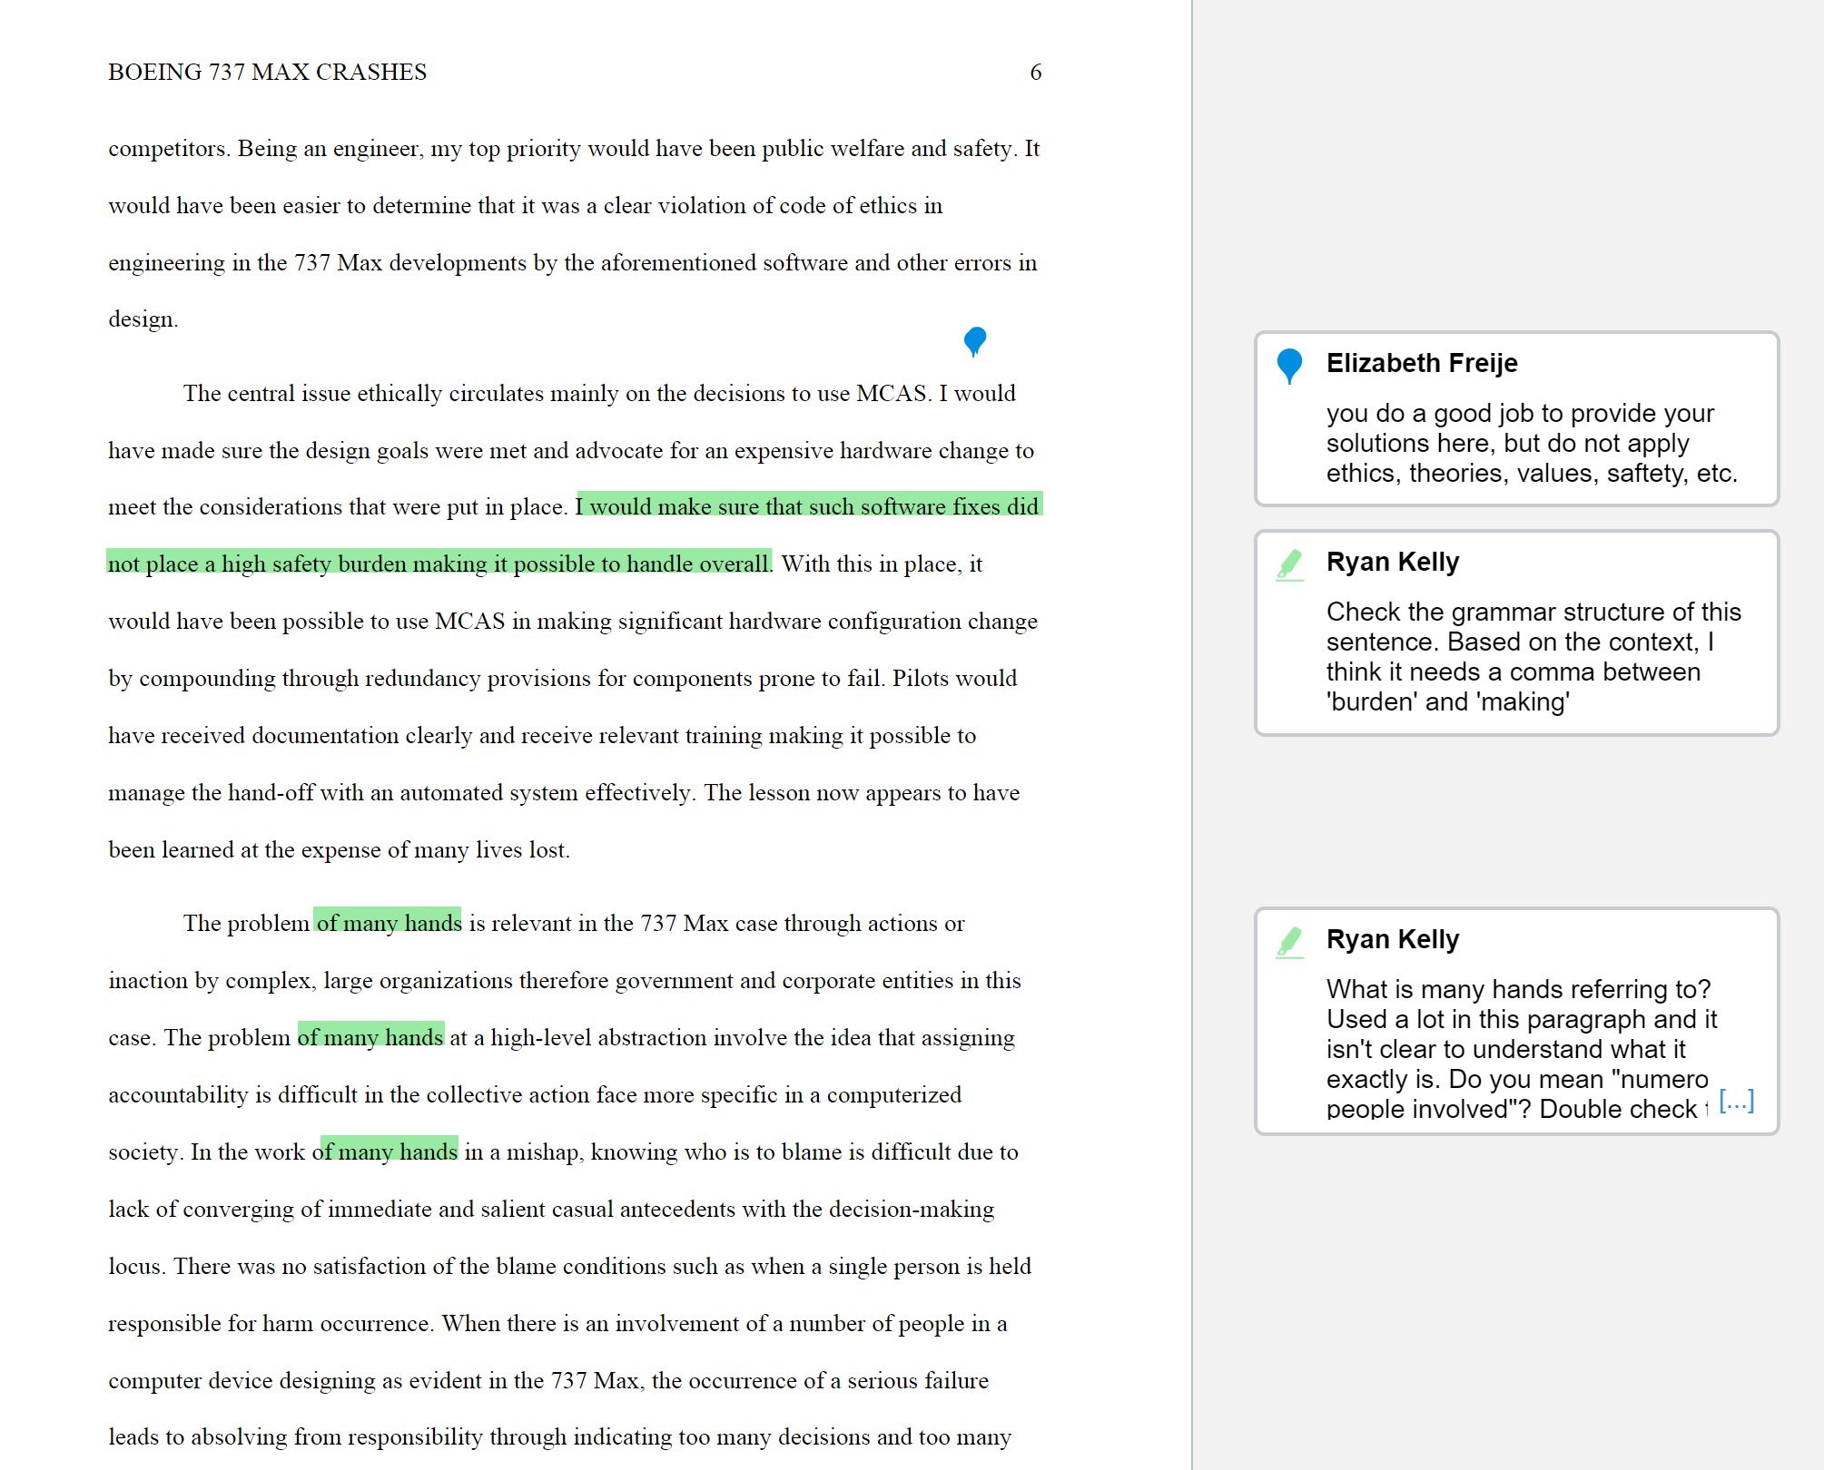

Your paper has a good outline to it. You do a good job of telling the story and providing the key issues of the story. However, you spend too much time re-telling the story and your thesis statement should be clear. Paper is vague/lacking when applying the various ethical theories, professional codes, and values. Also, your solution as to how the issue should be handled, backed with these ethical points, is also vague. Remember, majority of the grade for this paper comes from your ability to apply ethical analysis using the ethical code and theories learned in this class. Paper is lacking in in-text citation. You have several references in your list, but you do not include them in your paper. Only include the reference you use in your paper and make sure to in-text cite all statements that are not your own word or thoughts, this include even it you paraphrase it from original form.

